BRITISH RIDING CLUBS AREA 10

SUMMER DRESSAGE QUALIFIER 2019
JUNIOR AND SENIOR

Sunday 4th August 2019

Organised by Sevenoaks Riding Club

With kind permission of the Owlett Family
To be held at The Field, Underriver House Road, Underriver

Entries and secretarial enquiries to:
Mrs Fiona Whittington
Glebe Farm
Frant
East Sussex
TN3 9EN
01892 750002
07904 308458

fionawhitt@btinternet.com

All other enquiries phone June Burgess 01732 464293
Show day mobile: 07889 431474/ 07732 267121
CLASS 1 - Senior Intro Dressage Intro B (2009)

CLASS 2 - Senior Preliminary Dressage BD Prelim 12 (2005), Prelim 13 (2006), Prelim 14 (2006),
Prelim 15 (2008)

The highest placed 5 teams who do not qualify for the NAF Five Star National Championship will be eligible for the London and South East Championships

CLASS 3 - Senior Open Dressage BD Novice 24 (2010), BD Novice 34 (2009), BD Novice 38 (2005), BD Elementary 43 (2006)

CLASS 4 - Senior Riding Test BD Prelim 2 (2016) BD Novice 30 (2006)

The highest placed 4 teams who do not qualify for the NAF Five Star National Championship will be eligible for the London and South East Championships

CLASS 5 - Pick Your Own open to Junior and Senior BD Medium 61 (2002) or Advanced Medium 91 (2016)

CLASS 6 - Junior Dressage BD Prelim 2 (2016), BD Prelim 12 (2005), BD Prelim 13 (2006), BD Novice 30 (2006)

CLASS 7 - Junior Riding Test BD Prelim 7 (2002)
CLASS 8 - Junior Elementary BD Elementary 40 (2010)
CLASS 9 - Junior Intro Dressage Intro B (2009)

CLASS 10 - Junior pairs BRC Pairs 5 (2014)

CLASS 11 - Senior pairs BRC Pairs 5 (2014)

Please note: There may be changes to certain tests with the way that the collectives are marked and scored (the tests are not changing).

No horse may compete twice in the same team or in more than one team in the same class, they may be ridden in teams for the Senior Prelim, Senior Open and Senior Riding Test, or Junior dressage and Junior Riding Test. A horse may be ridden in more than one test in the same class if being competed individually and/or as part of a team. For Pick a Test competitions a horse may enter both Medium and Advanced Medium sections, but the sections will still be judged as one competition.
Horses may do more than one class along as eligibility criteria are met.

Entry fees: £64 per dressage team £16 per individual Pairs £25
Cheques made payable to Sevenoaks Riding Club.
Closing date for entries: Wednesday 24th July, 2019.

Late entries will not be accepted and no entries will be accepted over the telephone. All entries must be on an official entry form. Individual entries will be accepted. A preliminary entry must have been received by the Riding Clubs Office by Friday 12th July 2019 to be eligible to enter for the qualifier.
Withdrawals /Team changes: Should be made by email before Thursday 1st August 2019 and thereafter on the day.

Start times will be published on the Sevenoaks Riding Club website www.sevenoaksrc.co.uk and the Area 10 website www.brcarea10.org.uk on Friday 2nd August 2019.

Directions: to The Field, Underriver House Road, Underriver, Kent TN15 0SJ

PLEASE DO NOT FOLLOW YOUR SAT NAV, THE ROUTE WILL TAKE YOU DOWN LANES UNSUITABLE FOR SHOW TRAFFIC.

From the A21
Take the Hildenborough exit onto the B245 towards Tonbridge. Please do not turn into Bank Lane it is very narrow but take the 2nd turning on the left Mill Lane, on Mill Lane, take the 2nd turning on the right on to Underriver House Road.

From Tonbridge (A26)
Follow B245 to Hildenborough, go past the Church and turn right into Mill Lane, take the 2nd turning on the right onto Underriver House Road.

From Borough Green (M20, M26)
From the A25 turn onto the A227 at the roundabout towards Tonbridge, stay on A227 through Ightham to Shipbourne. Pass the Chaser pub on your right and at the cross roads by the school, turn right onto Hildenborough Road. At the end of the road turn right onto Underriver House Road.

Equine influenza certificate: All competitors must have an up to date Equine Influenza Certificate which must be, upon penalty of elimination, accompany the horse to this competition and the competitor is responsible for producing it on demand. For all those horses not on the Area database, a photocopy must be sent to the Entries Secretary with the official entry form. All vaccination certificates must be checked at the Secretary’s before collecting your number.

Helpers: Any club entering: Any club entering a team must provide one helper per team or one helper per two individual entries (entries will not be accepted without this information). A Club Helpers Form (available via http://www.brcarea10.org.uk/downloads.html) must be provided with the Area Entry Form.

General rules and conditions of entry
To be run under BRC official rules 2019

- All entries are accepted only upon the terms of the general rules and conditions below. Your signature on the entry form shall be deemed to be an acceptance of the rules and conditions.

- The judges’ decisions are final.

- In the event of cancellation of this event £2 shall be retained from each competitor to cover administrative expenses.

- Health and Safety. The organisers of this event have taken reasonable precautions to ensure the health and safety of everyone present. For these measures to be effective, everyone must take all reasonable precautions to avoid and prevent accidents and must obey the instructions of the organisers and all officials and stewards.

- Disclaimer of liability. Save for the death or personal injury caused by the negligence of the organisers or anyone for whom they are in law responsible, neither the organisers of any event to which these rules apply, nor the British Horse Society, nor any agent, employee or representative of these bodies accepts liability for any accident, loss, damage, injury or illness to horse, owners, riders and spectators, vehicles, land or any other person or property whatsoever, whether caused by negligence, breach of contract or in any other way whatsoever.

- Protective Headgear ‐ Everyone mounted, whether competing or not, must wear a hard hat with a harness properly adjusted and fastened. Failure to do so will incur elimination. Due to a change by the European Commission regarding EN1384 and BSEN1384 no longer being an accepted standard, all hats which only meet the standard EN1384 or BSEN1384, and do not comply with another standard from the below list, WILL NOT be accepted and therefore will not be permitted for any BRC competition. Hats which bear EN1384 or BSEN1384 along with another standard from the below list, will be tagged. For example, BSEN1384 & PAS015 (1998 or 2011) along with the Kitemark, would be acceptable, but not BSEN1384 on its own.

For 2019, hats must be tagged with aqua tags. Bring hats for tagging to the Secretary’s before riding.

7) All lorries and trailers must be parked in an orderly fashion in the designated parking areas only. Do not muck out your box in the lorry park.

8) All dogs must be kept leads.

BRC Hat Guidelines 2019 V1
Only hats to the following specification are acceptable at ANY BRC competition.
At all BRC Area Qualifiers and Championships, hats must show a visible BRC blue ‘hat tag’.
Any other standards / dates are NOT acceptable and will not be tagged. Hats must meet ALL of the requirements of one of the following rows:

 | Standard and Date | Quality Assurance  Mark | Examples
1 | PAS 015  (1998 or  2011) | AND MUST HAVE  BSI Kitemark  Or Inspec IC Mark |  | 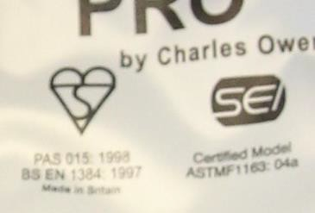 | 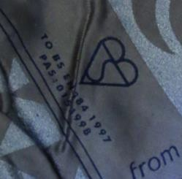
2 | VG1 01.040  (2014-12) | AND MUST HAVE  BSI Kitemark  Or Inspec IC Mark |  | 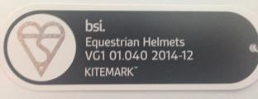 | 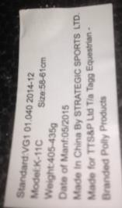
3 | ASTM F1163  (2004a or 04a onwards) | AND MUST HAVE  SEI mark | 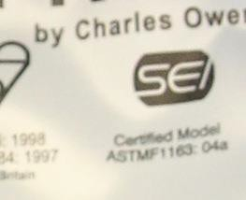 | 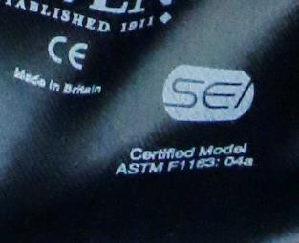 | 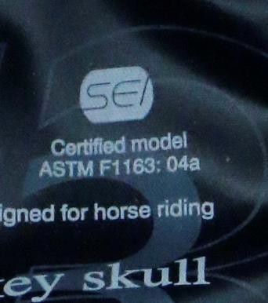
4 | SNELL E2001  or E2016 | AND MUST  HAVE  Official SNELL label and number  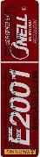 | 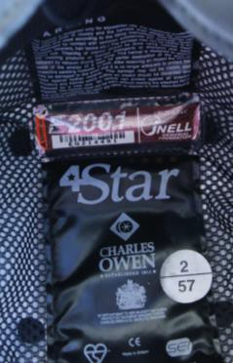 | 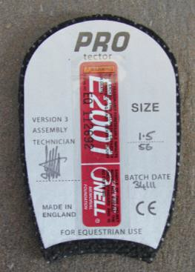 | 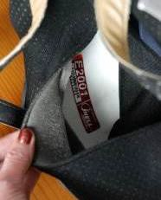
5 | AS/NZS 3838  (2006  onwards) | AND MUST  HAVE  SAI Global mark

