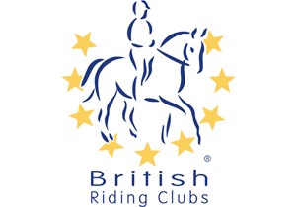

BRC AREA 10
Junior & Senior BRC Arena Eventing Qualifiers

To be Organised by Rother Valley Riding Club

Sunday 13th January 2019

At

PETLEY WOOD E.C
Marley Lane
Battle, East Sussex, TN33 0RE

ENTRIES TO:
Dinah Smith
Clovelly High Street, Etchingham
East Sussex, TN19 7AG
Telephone: 07703 794277
E-mail: nickanddinah@yahoo.com

Photographer: LRG Photography

Class 1 BRC AE 70 Mixed Senior and Junior teams and individuals
Teams may be any combination of senior and/or junior. The best three scores to count.

Class 2 Junior BRC AE 80 Qualifier for teams and individuals
The best three scores to count.

Class 3 Senior BRC AE 80 Qualifier for teams and individuals
The best three scores to count.

Class 4 Junior BRC AE 90 Qualifier for teams and individuals
The best three scores to count

Class 5 Senior BRC AE 90 Qualifier for teams and individuals
The best three scores to count

Class 6 BRC AE 100 Qualifier Mixed Senior and Junior teams and individuals
Teams may be any combination of senior and/or junior. The best three scores to count.

The Course: Consists of show jumps immediately followed by cross country fences and will finish with the last fence as a show jump, the joker fence, which will be set at a discretionary 10cm higher than the rest of the course. There will be a maximum of 20 jumping efforts, 9 show jumping, 10XC fences and the joker SJ fence.
NO WATCHES/STOP WATCHES ALLOWED

Entry fees: £80 per team of 3 or 4 team members
£20 per individual

Entries: Please note that in addition to the entries to the local organiser (see below), for the national qualifiers preliminary entries must be made to the British Riding Clubs’ Office no later than 21 days before the date of this qualifier: 23rd December 2018

Entries to: Dinah Smith, Clovelly High Street, Etchingham, East Sussex, TN19 7AG

Entries close Friday 4th January 2019

Enquiries: Telephone: 07703 794277 E-mail: nickanddinah@yahoo.com

Times: Times will be available from Thursday 10th January 2019 on www.brcarea10.org.uk

Rules: To be run under BRC rules 2019. Eligibility for horses and riders as per the BRC rules

The passport / equine influenza record for each horse must be brought to the competition and will be checked on the day.
Hats and body protectors will also be checked before numbers are issued to competitors

PLEASE NOTE YOUR OWN NUMBER BIB WILL BE REQUIRED

Helpers: Please can each Club provide 2 half day helpers per team or 1 half day helper per 2 Individuals or their equivalent (can be 1 x full day helper or 2 x half day helpers) Names and phone numbers to be submitted with the entries.

The course will only be open for walking on the day of the competition.

Objections: Any objection may only be made by the team manager of a club competing in the event. Any such objection must be made to the Official Steward immediately and in writing to the Secretary within 30 MINUTES of the incident with a deposit of £20, such deposit returnable within 7 days if the objection is upheld.

CONDITIONS OF ENTRY

- All classes will be run under the current BRC rules:

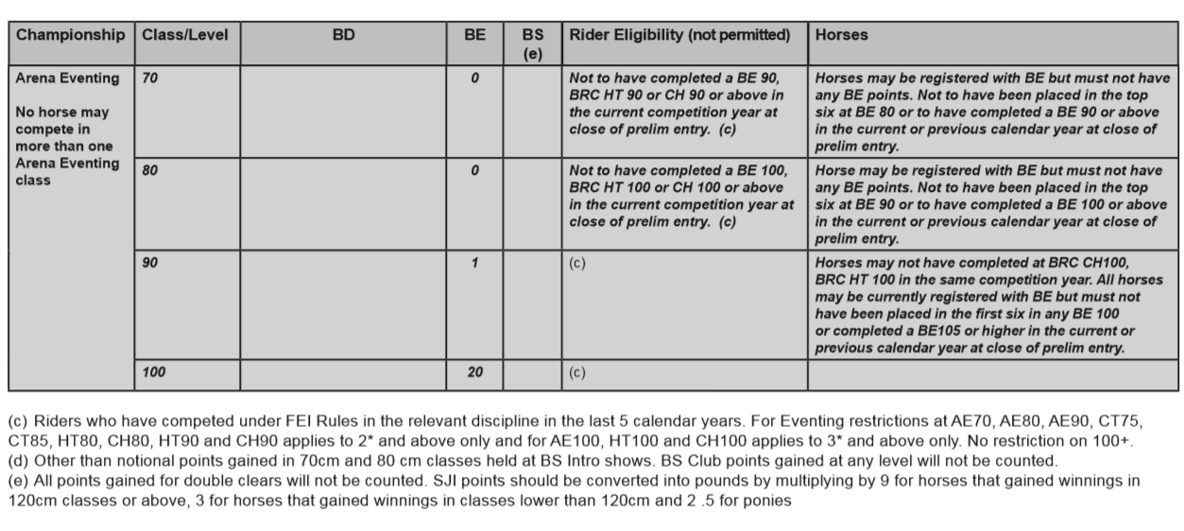
:

2. Dress:
Correct riding attire must be worn by all competitors. Dress guidelines are the same as Horse Trials and FOTH Challenge – Cross Country attire, including a current standard body protector and Skull cap with silk fitted. No fixed peaks allowed. Everyone mounted, whether a competitor or not, must wear a hard hat, complying with the current standards, with the harness properly adjusted and fastened. Failure by a competitor will incur elimination. Long hair must be tied back and up so as to be no longer than shoulder length.

3. Disclaimer of Liability:
Save as stated by law, no claim can be entertained for anything that may happen to competitors, their property, servants, or horses in connection with, or arising out of this event. It shall be deemed a condition of entry that each entrant shall agree to indemnify the organisers, their servants or agents against any legal action arising from any such incident.

4. Entries:
No entry will be accepted unless accompanied by the correct fee. No entry fee will be refunded unless a veterinary or medical certificate is produced no later than 4 days after the event. Entries may be refunded less a small administration fee.

5. Organisers’ Rights:
The organisers reserve the right, without giving a reason, to refuse any entry and/or alter, amend, cancel or amalgamate classes. The decision of the organisers, judges and stewards is final.

6. Health & Safety:
(a) The event is organised in accordance with H & S legislation. The organisers will take all reasonable precautions to ensure the safety of those attending the event. For these measures to be effective everyone attending must take similar precautions to prevent and avoid accidents and obey the instructions of the organisers, stewards, judges and other officials.
(b) No dogs allowed.
(c) Horses/ponies must not be tied up outside boxes/trailers unaccompanied.
(d) If any horse/pony has been in contact with any infectious disease it should not attend this event.
(e) No lunging is allowed in the parking or warm-up areas.
(f) All vehicles should enter and leave the parking area with due consideration for others and vehicles should be parked in a sensible manner.
(g) Hay and other rubbish must not be left on the showground and droppings should be removed.

